Project Report
Project Name : Smart Irrigation System.
Project Members :
- Sheth Priyam (190280111131)
- Sharma Paryan (190280111130)
- Thakkar Akash (190280111139)
- Chauhan Mihir (200280111502)
Project Guide : Prof. K.G. Vaghela
Project Date : 10TH NOV, 2022
Project Components :
Sr. No. | Components | Quantity
1. | ESP8266 (NodeMCU) | 1
2. | Soil Moisture Sensor | 1
3. | Relay | 1
4. | Connecting Wires | 1
5. | Pump | 1
6. | 9V Battery | 1

Project Schematic Diagram :
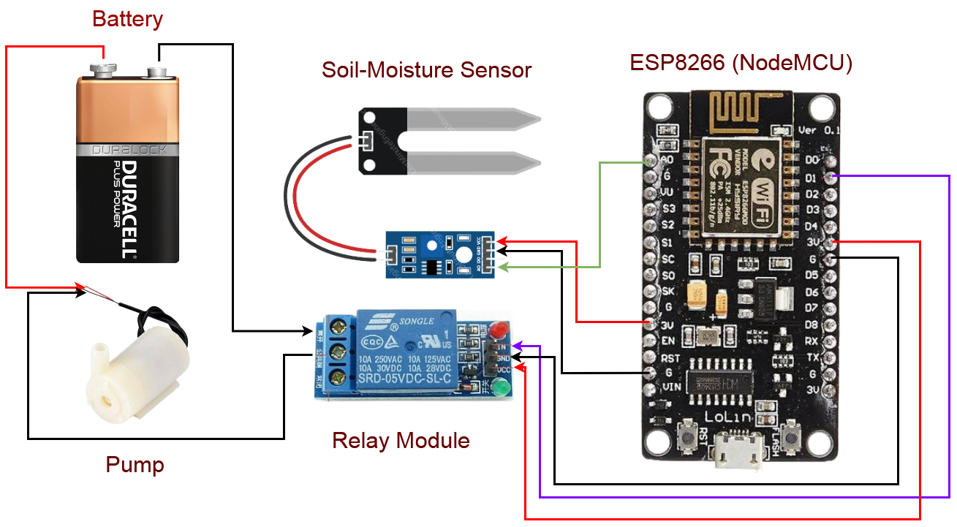
Project Working :
Firstly, all the components are connected according to the Schematic Diagram shown in the above figure. Then, the Soil Moisture Sensor will detect the humidity present inside the soil. A Relay is connected with the system which works as a magnetic switch. In this relay, the input is taken from the sensor and after detecting the sensor input it will switch on and off the pump. If the humidity is detected and is high from a certain value then it will switch off the Pump and if humidity is low from a threshold value then it will switch on the Pump. The Data of Sensor is collected and stored in the Database which is a Google Firebase. Then, the data is retrieved from the database and is shown on the Website using HTML, CSS and JS. The Data which is shown on the website are the Humidity and the Status of the Pump.

Project Shots :
